**Date of Experiment:**

**Date of Submission:**

**SVKM’S NMIMS**

**Mukesh Patel School of Technology Management & Engineering**

Department of Mechatronics Engineering

**RPA - Lab**

Subject- Robotic Process Automation

**EXPERIMENT NO. 8**

**Objective:**

The objective of this experiment is to understand the capabilities of Microsoft Power Apps. This experiment involves creating a CRUD based application from an excel table and making a form from a hand drawn form.

**Prerequisites:**

1. Computers or laptops with access to Internet.
2. Power Apps account
3. An Excel sheet with sample data.
4. Hand-drawn forms.

**Theory:**

**1. Overview of Power Apps**

Power Apps is a Microsoft platform that enables users to create custom applications without extensive coding. It's a powerful tool for app development with a user-friendly interface.

**2. Introduction to CRUD Operations**

CRUD stands for Create, Read, Update, and Delete – fundamental operations in database-driven applications. In this experiment, you'll learn to implement these operations using Power Apps.

**Task List: Intro To Power Apps**

1. **Creating a CRUD-Based App from Excel**
   * Creating a CRUD based application on Power Apps is very easy and intuitive.
2. **Creating an App from a Hand-Drawn Form**
   * Generating an form from the layout drawn by hand is a very effective way of designing and developing a form this helps in reducing the timeline of development

**Procedure Overview:**

1. **Creating a CRUD-Based App from Excel**
2. Open Power Apps and create a new app.
3. Import sample data from the provided Excel sheet.
4. Understand the structure of the data and columns.
5. Establish data connections between Power Apps and the Excel sheet.
6. Explore data sources and understand how Power Apps interacts with external data.
7. Create screens for viewing and editing data.
8. Customize the layout and design of each screen.
9. Add functionality to create new records.
10. Enable editing and updating of existing records.
11. Implement the ability to delete records.

**2. Creating an App from a Hand-Drawn Form**

1. Receive a hand-drawn form for the exercise.
2. Understand the fields and functionalities represented in the form.
3. Use smartphones to capture images of the hand-drawn form.
4. Save images for reference in Power Apps.
5. Import the captured images into Power Apps.
6. Design an app based on the hand-drawn form, replicating fields and functionalities.
7. Customize the app layout and design.
8. Add creative elements to enhance the user experience.

**CRUD Application:**

1. **Create Screen**
2. **Read (With Delete Icon Marked) Screen**
3. **Update Screen**

**Home Screen:**

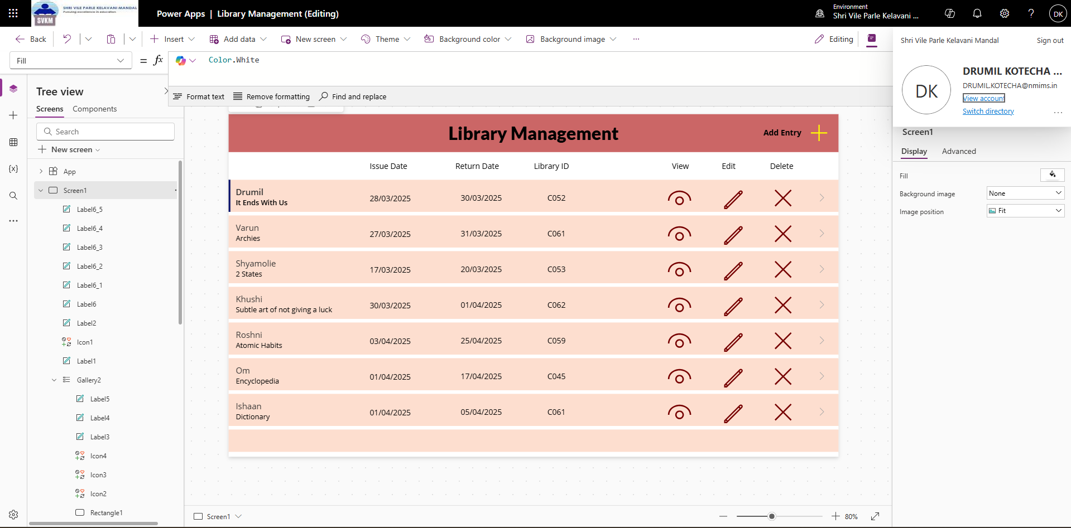

**Form Screen:**

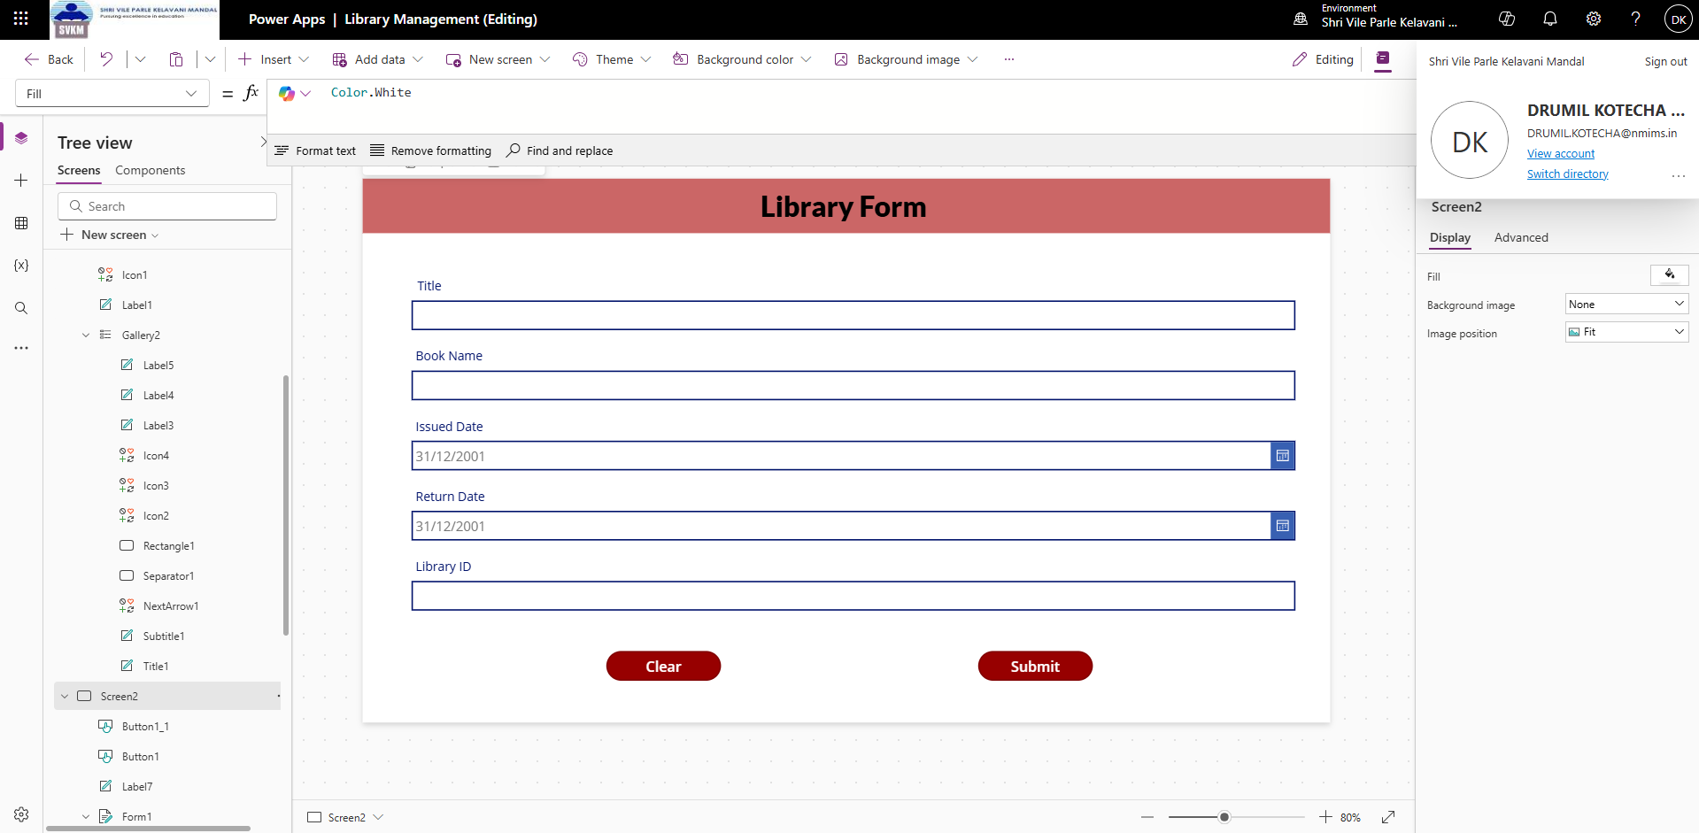

**Create:**

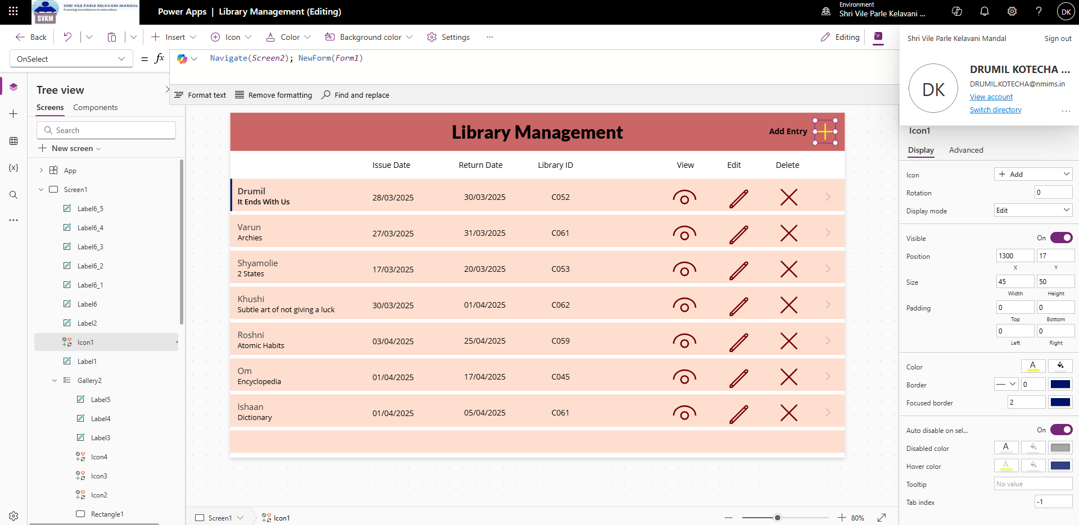

**Read (View):**

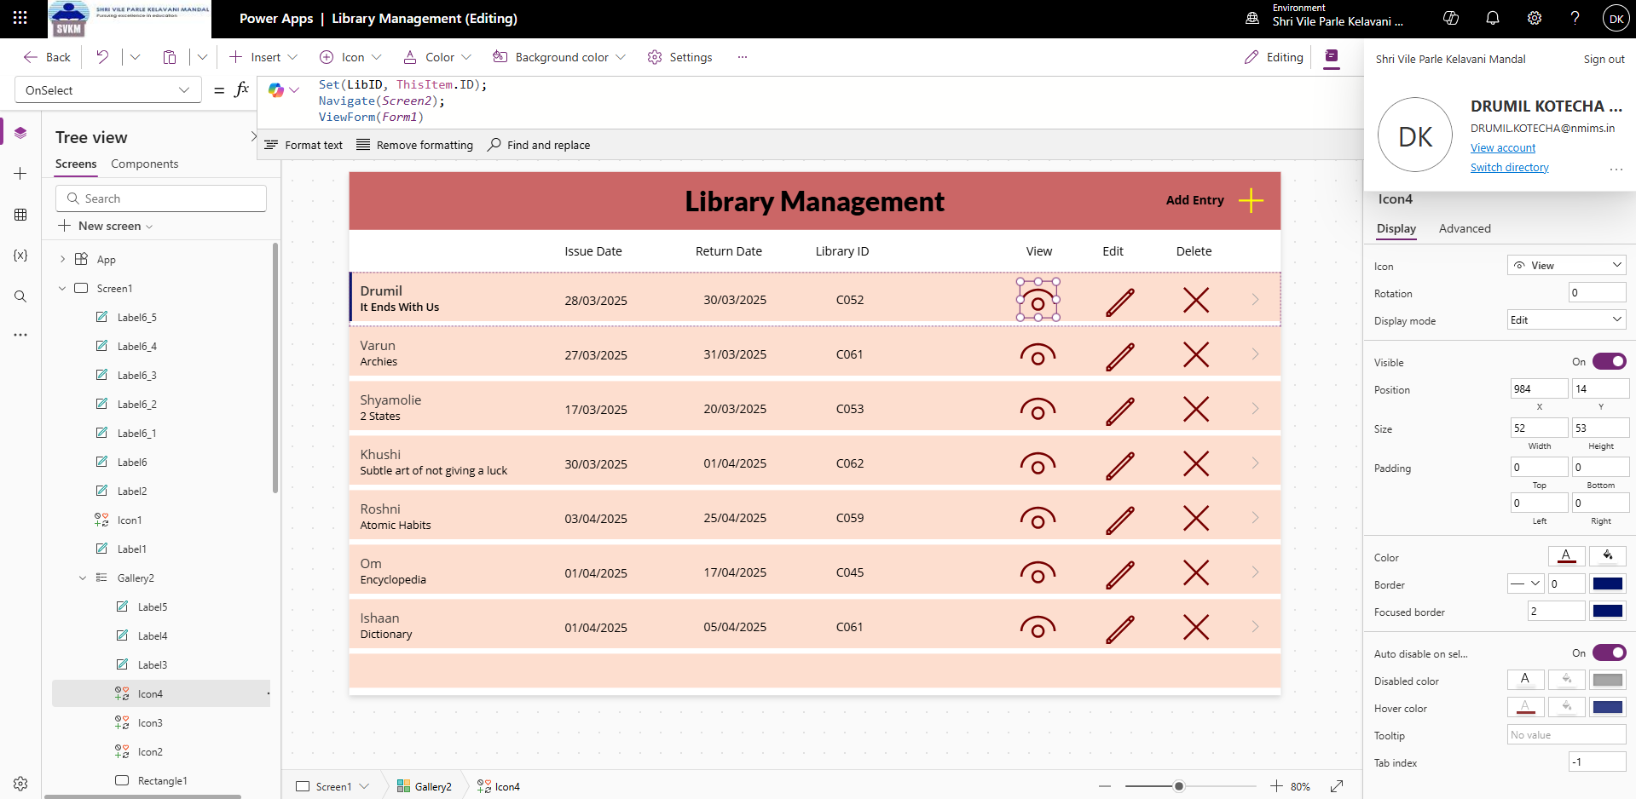

**Update (Edit):**

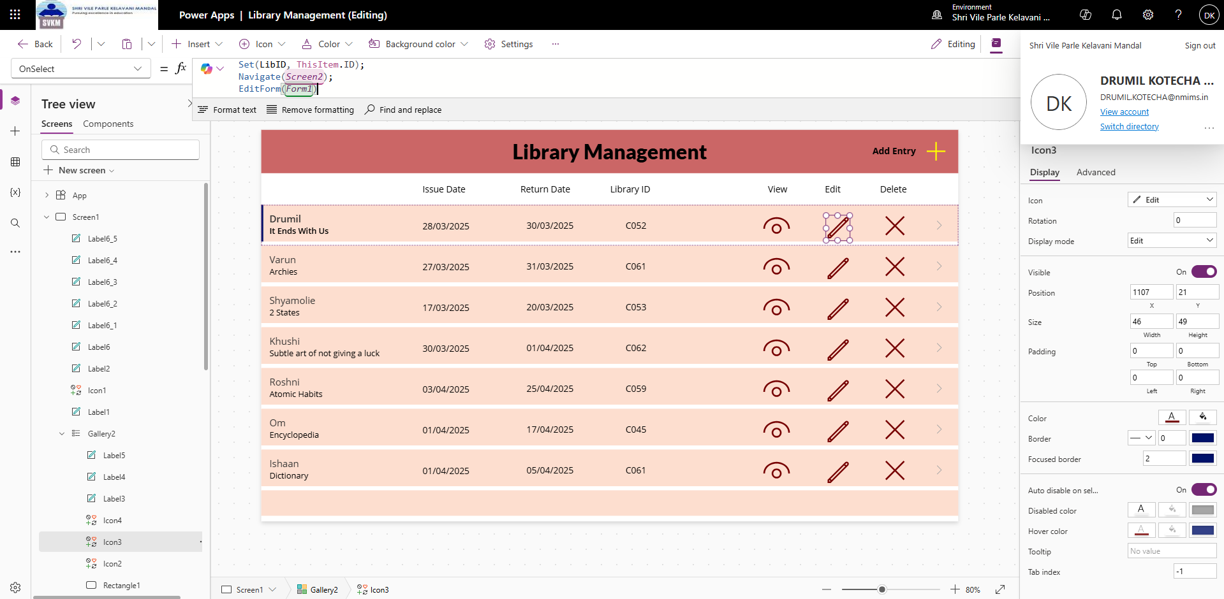

**Delete:**

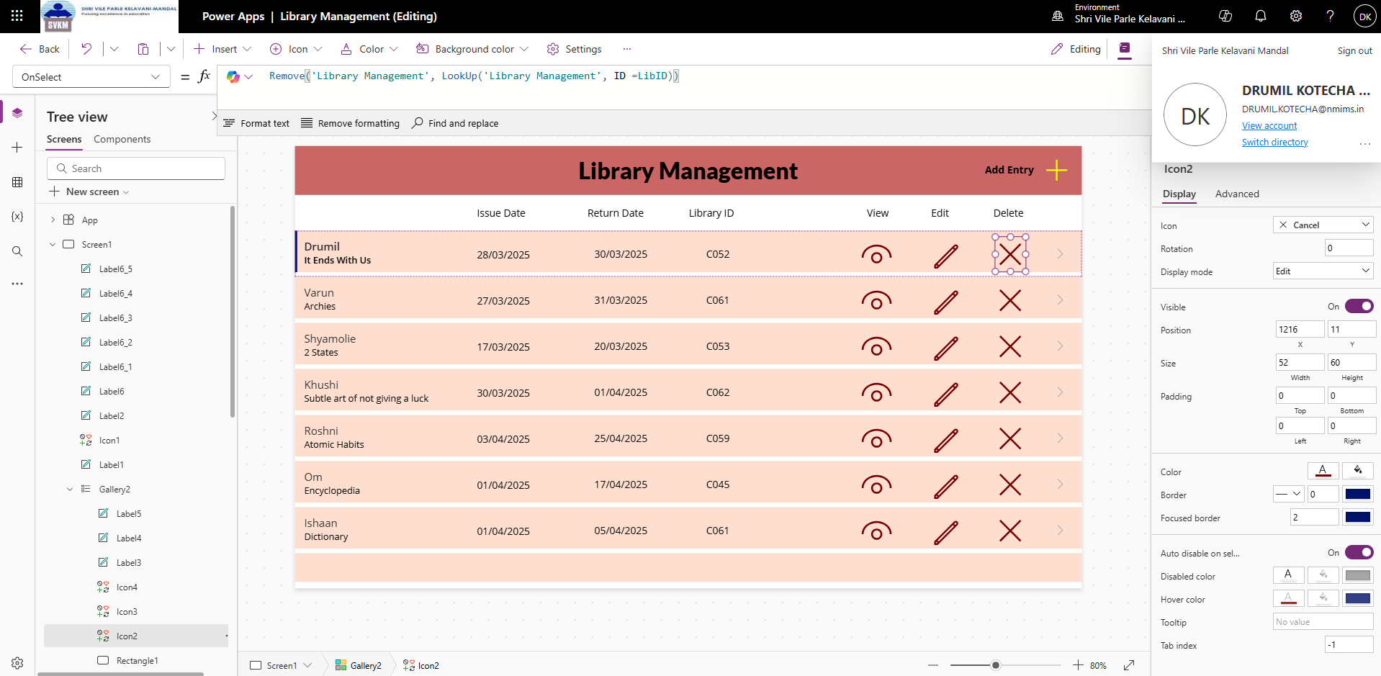

**List: https://svkmmumbai-my.sharepoint.com/personal/drumil_kotecha_nmims_in/Lists/Library%20Management/AllItems.aspx?env=WebViewList**

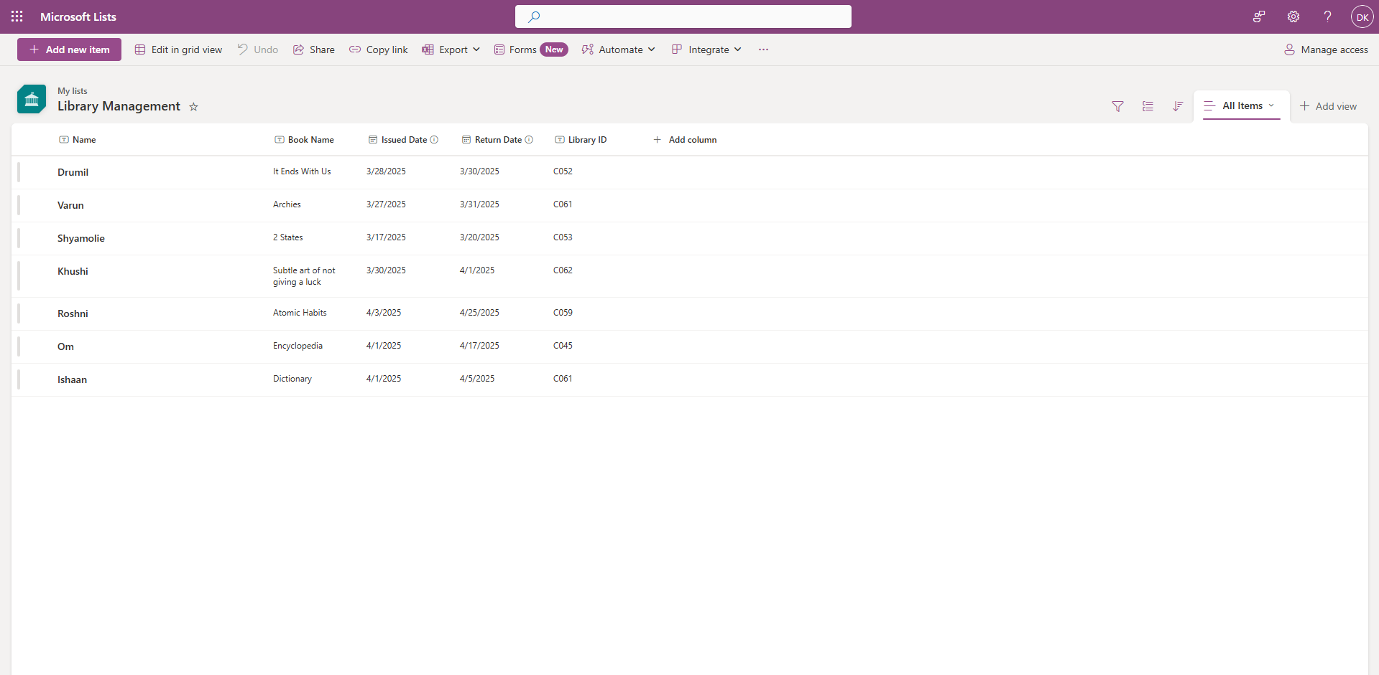

**Conclusion:** CRUD stands for Create, Read, Update, and Delete – fundamental operations in database-driven applications. In this experiment, I learn to implement these operations using Power Apps.